Staging Site Changes – 28.10

1
Change sage green colour to: #7D9A8B

2
Pricing Page
Can you change the layout of the pricing page to be like this:
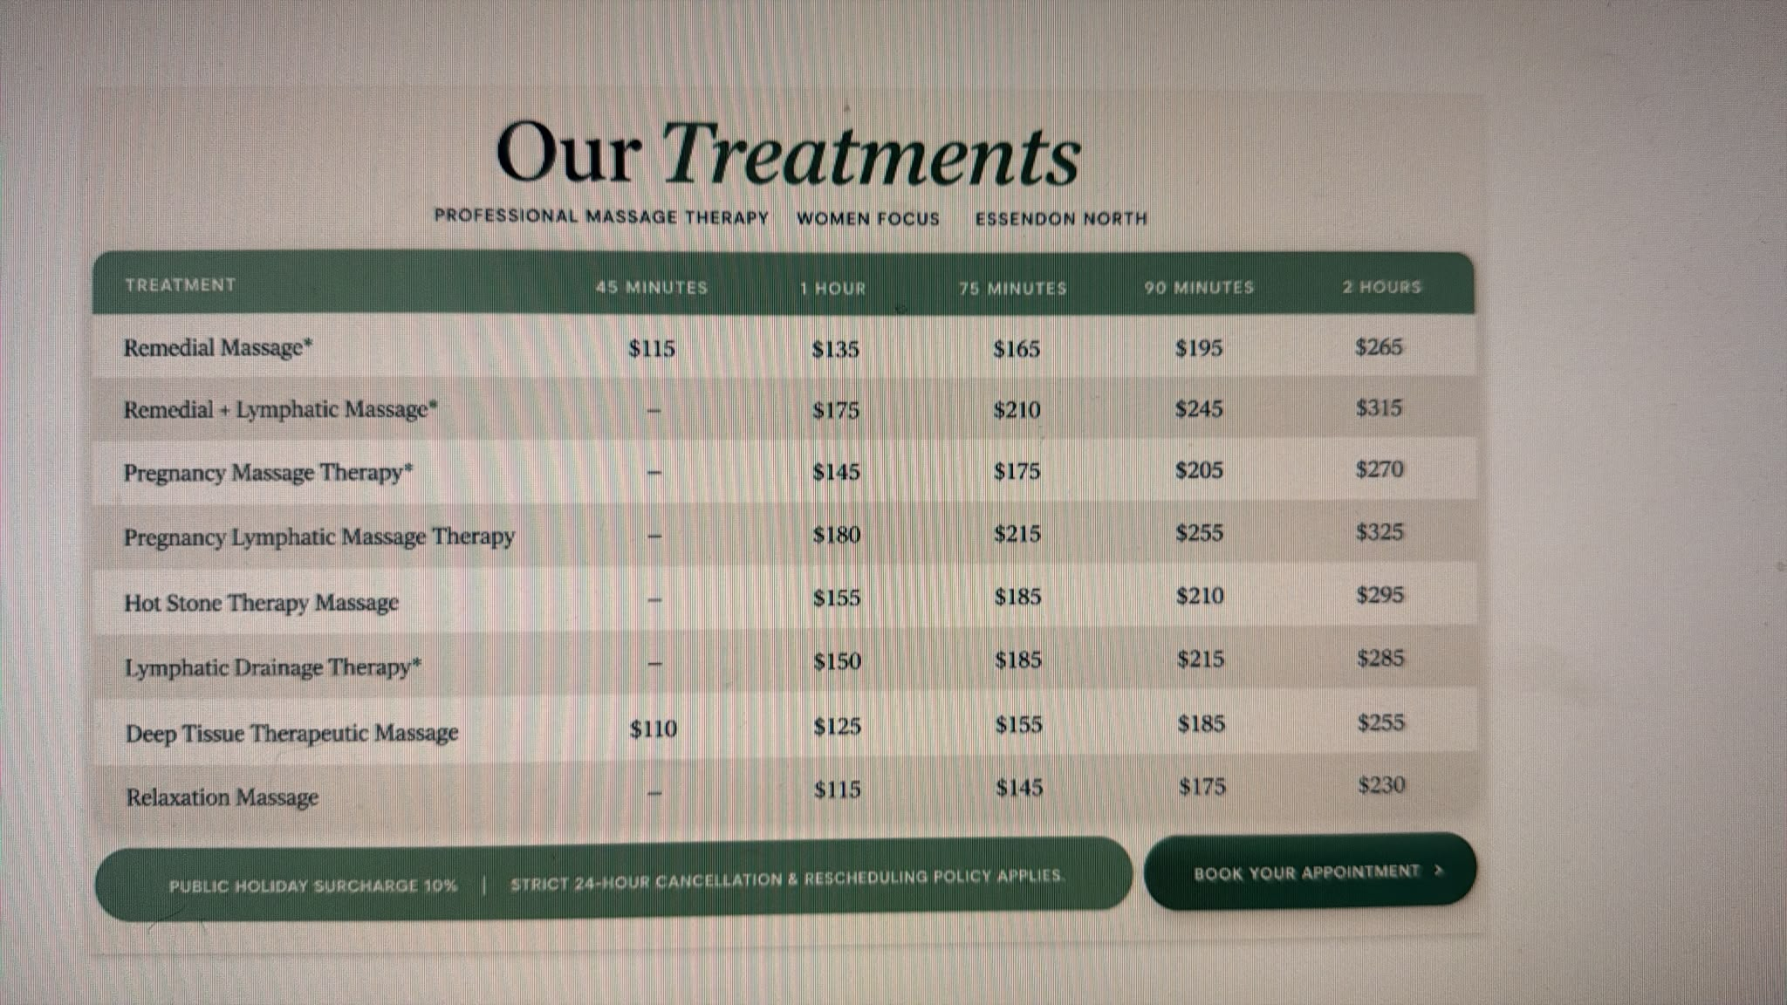

3
Home Page
Female-focused text – try to unbold and remove all caps
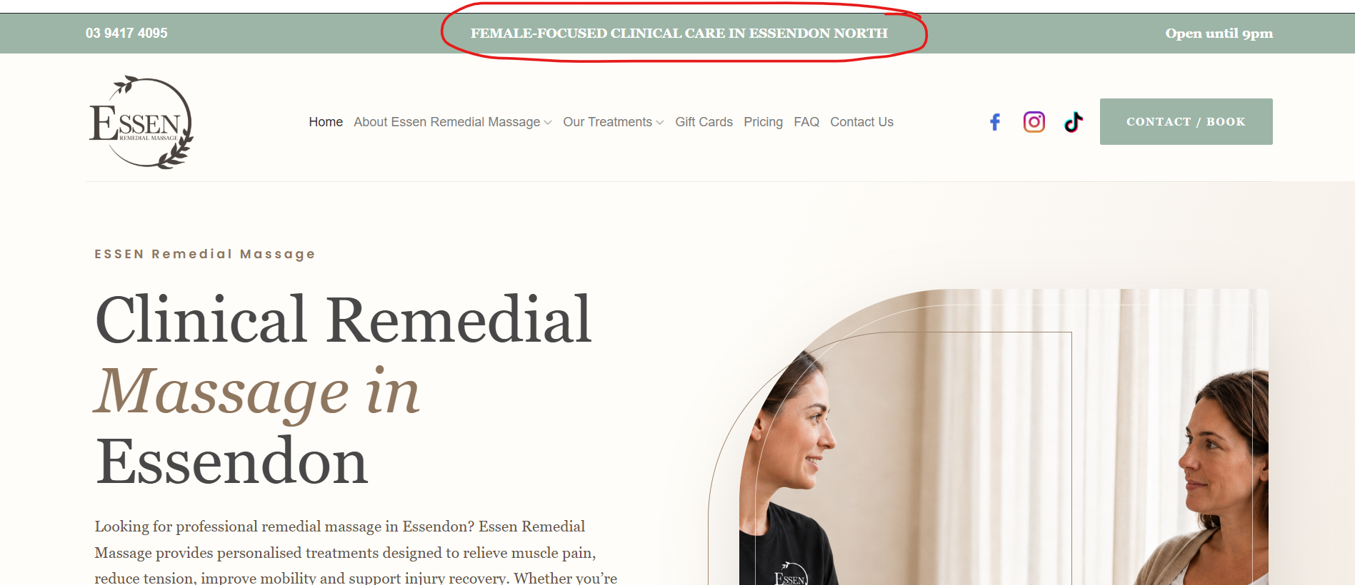

Make the menu darker in font colour, larger and add more space in between menu items
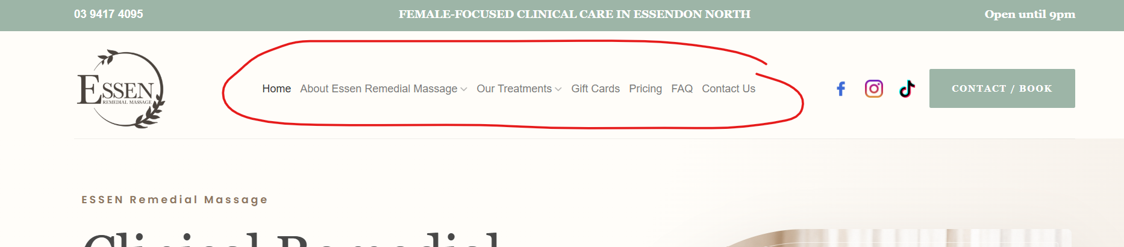
Banner – the client wants to remove the lines from the image and make the image wider (keeping the shape/arc of the image) – client to provide image.
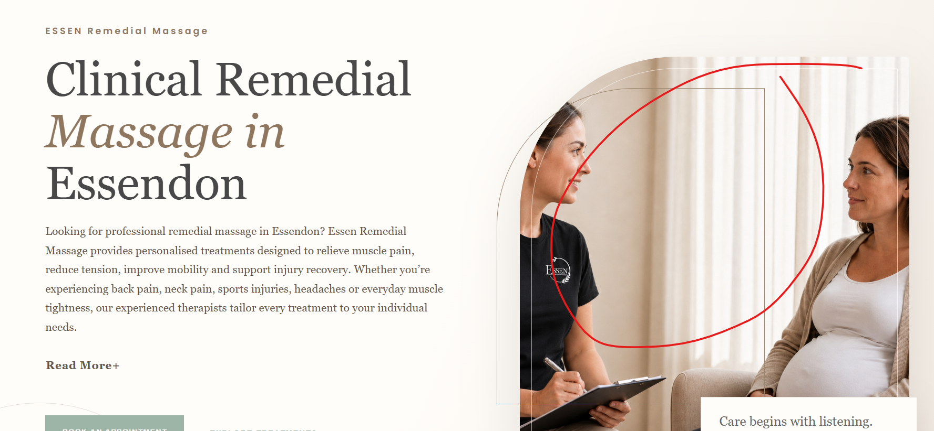

4
Treatments Page
Change Book Now to a button
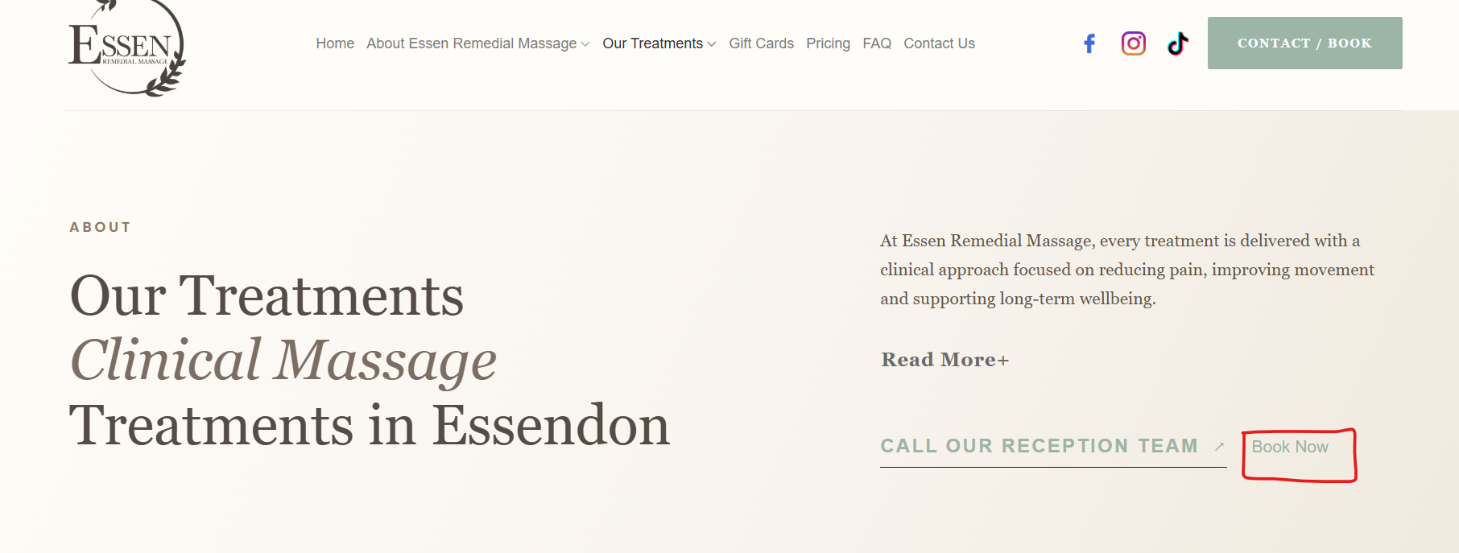
Minutes – add a background to these:
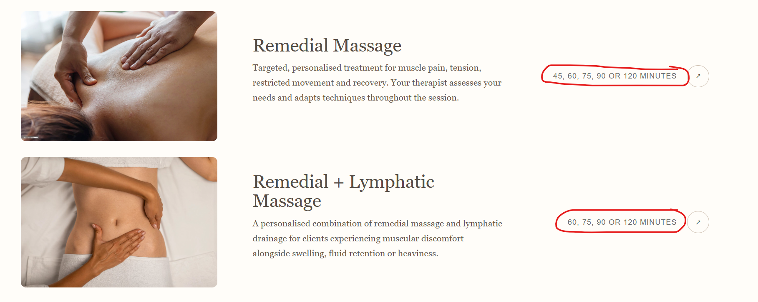
Arrow button – change bg colour to sage
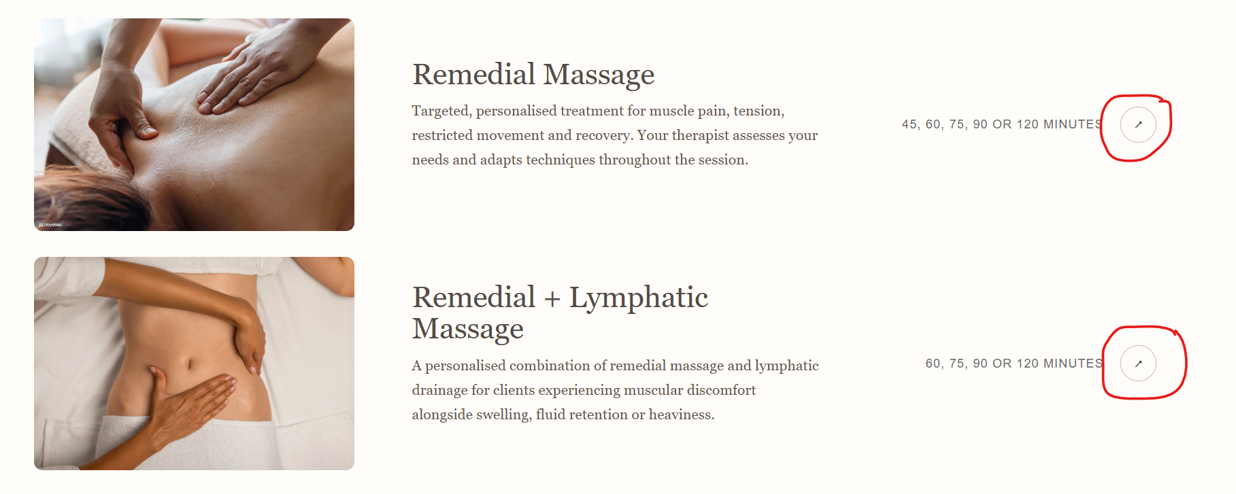
Change Pregnancy Lymphatic Massage image
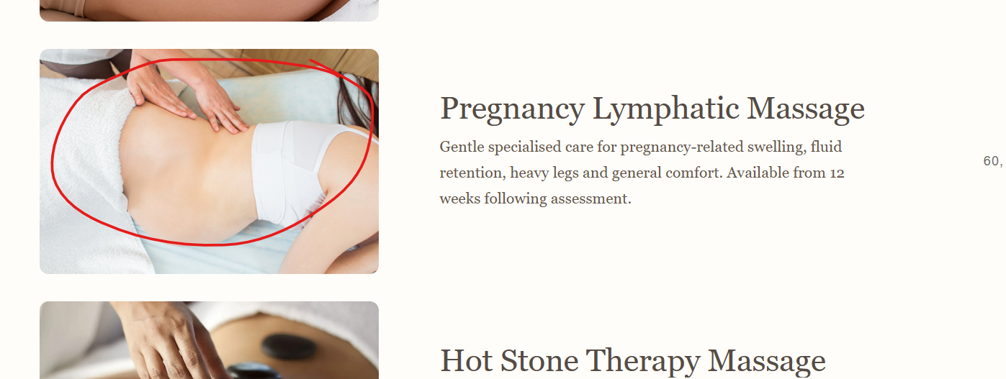

5
About Page
Banner image – make it longer so the image doesn’t look cut-off at the bottom and the desk can be seen
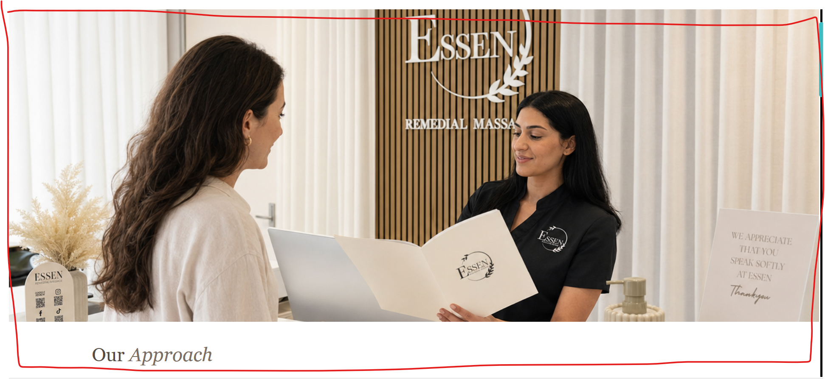
6
All Clinic Image
Change all references of this clinic image to a new image to a clinic with receptionist. Use _47A0643.jpg
https://drive.google.com/drive/folders/1bGDPtp_uZlTBjHLWXhexBC6VnPq-Uokm?usp=sharing
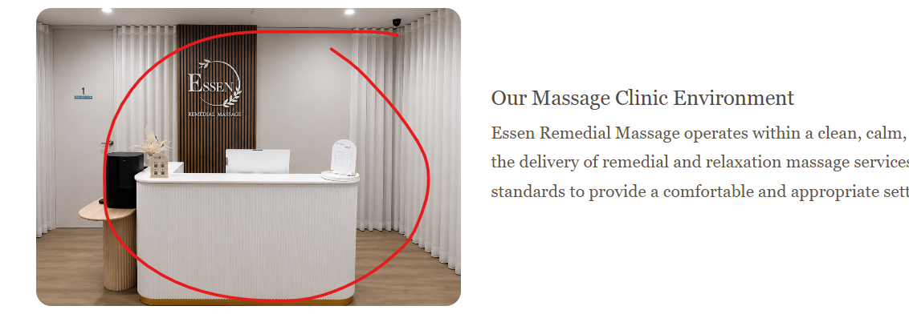

7
Frequently Asked Questions
Change image to Rani and old lady. Use _47A0429.jpg
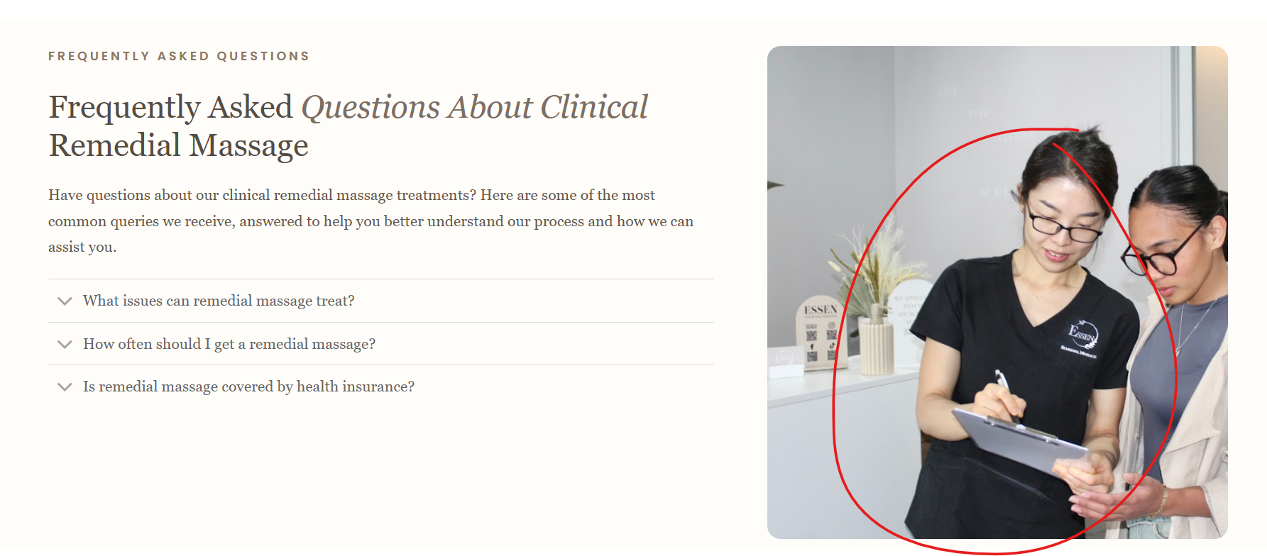
8
Other Treatments
Clinical Lymphatic Drainage image
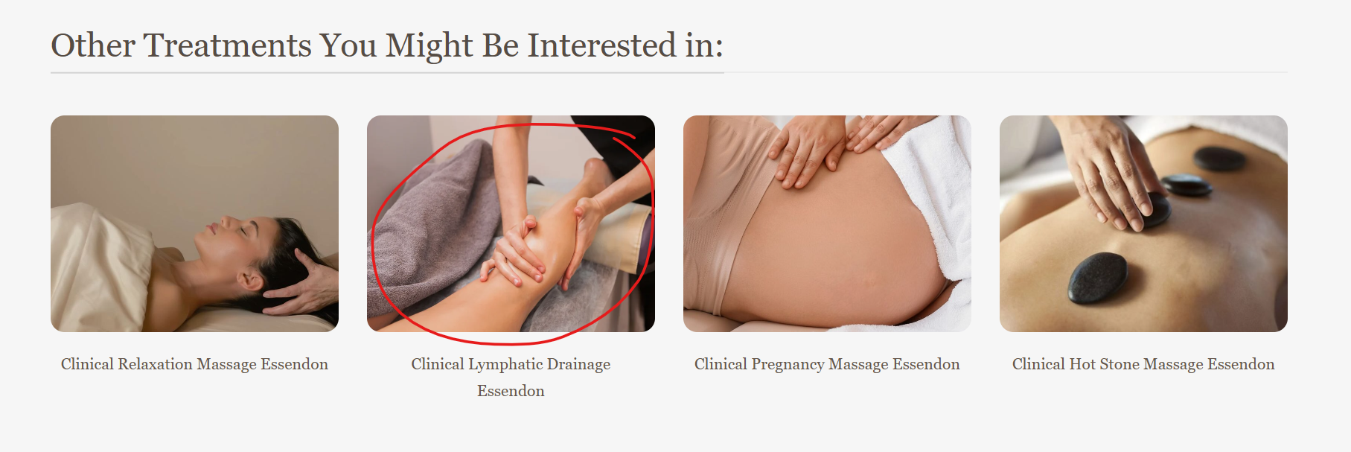
To
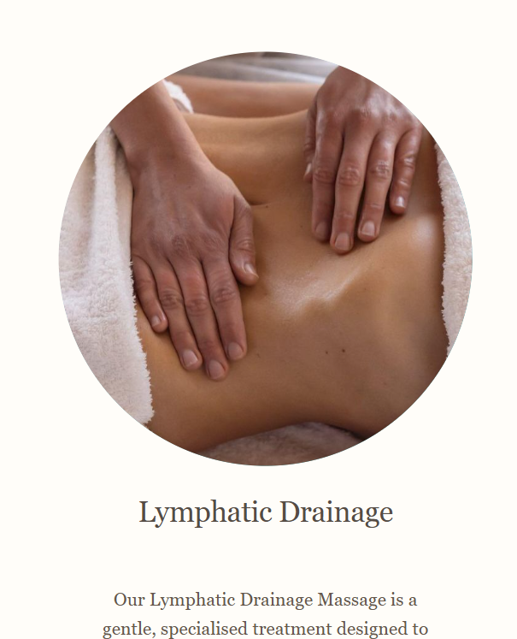
Change Pregnancy Lymphatic Massage image
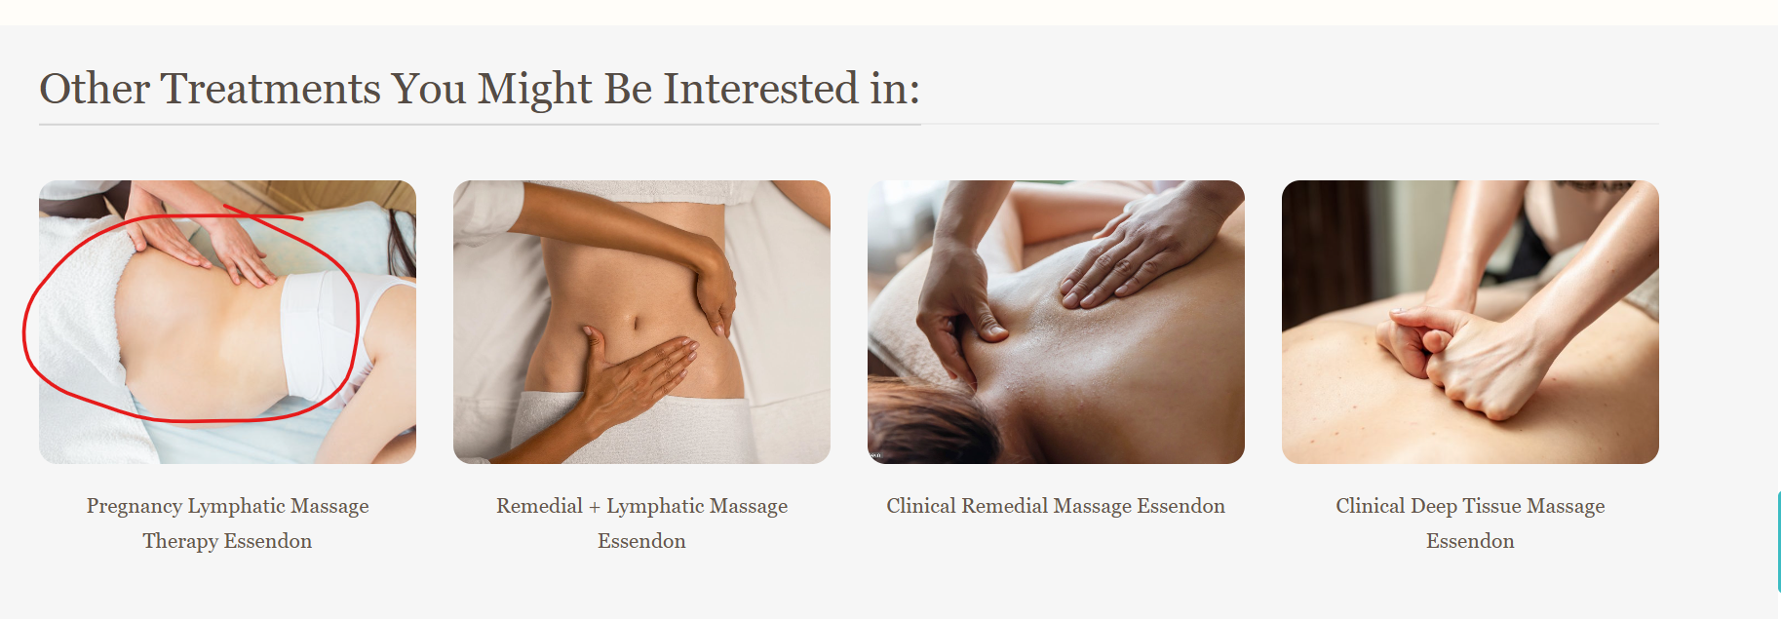
9
Blog
Add Read More for each post
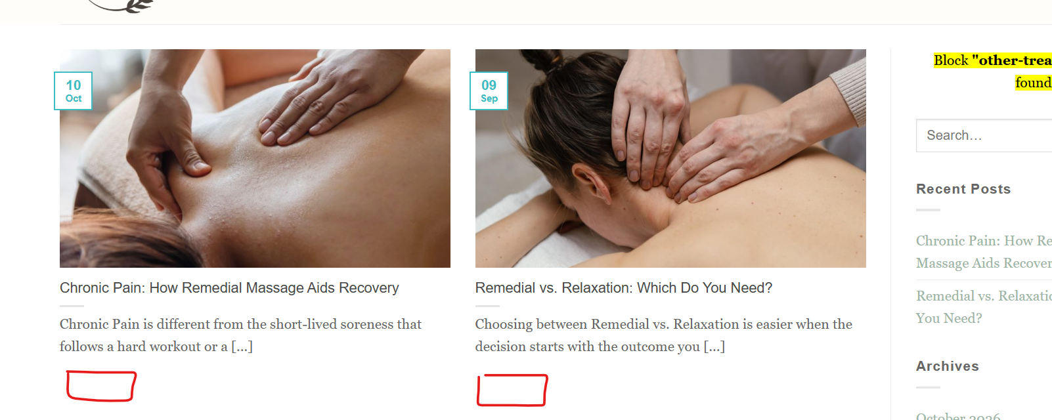
10
Testimonials
Change white background to a different colour that matches the branding
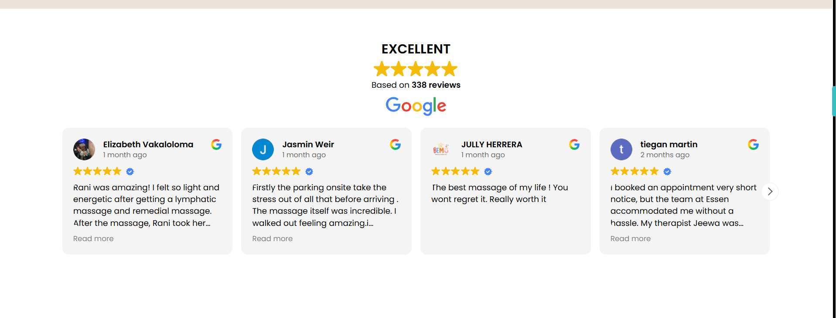
11
Remedial Massage Page
Change Rani’s image to _47A0449.jpg
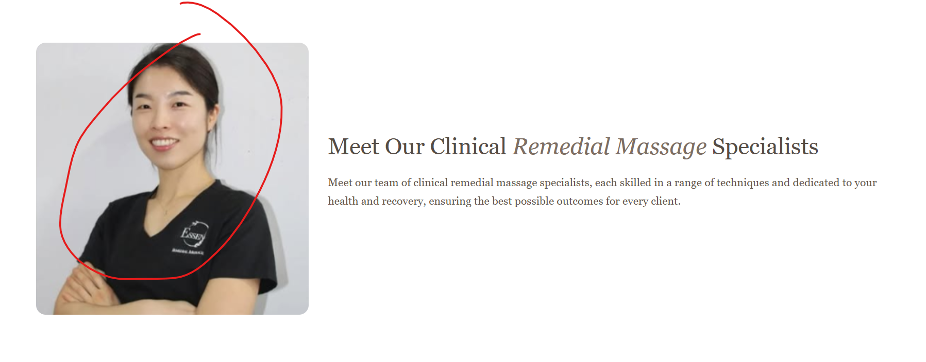
12
All Treatments Page
Change layout of the banner
Banner Title (full width or centered)
Banner Description (full width or centered)
Banner Button (full width or centered)
Banner Form (full width and centered, make the form wider)

13
Gift Cards
Change buttons to sage colour

14
Footer
Change background colour to sage green and logo and text to white

15
Contact Us
Can we change the layout
Have the contact details in one row 3 columns
Move the form below the contact details and make it wider
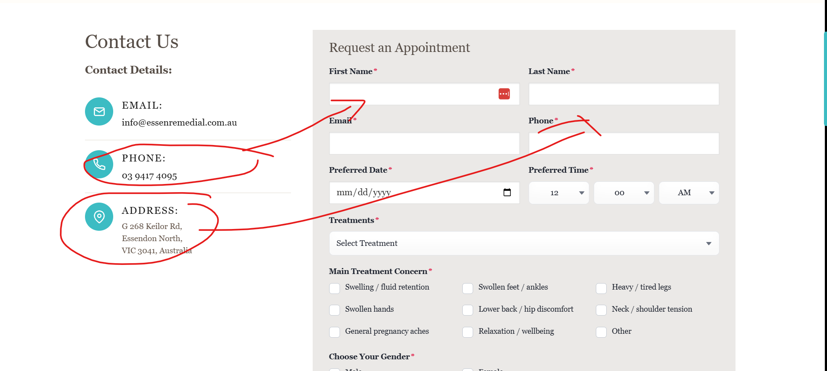
16
All Links and Buttons
Change to sage green colour, even the hover colour

